**Laboratory Exercise 11.1 - Using Oracle’s CUBE and ROLLUP functions**

1. Examine the text file called *ExampleUsingOracleCube&Rollup.txt* stored in this directory.

2. Design a table similar to the Sales table from that file, to hold information about individual items purchased in a grocery store. Records will include a customer number, a day, an hour using a 24-hour clock, an item name, and a price such as

1, Monday, 10, bread, 2.49

2, Monday, 14, milk, 1.99

**CREATE TABLE sales_info (**

**customer_number NUMBER (2),**

**day_of_week VARCHAR2 (10),**

**hour_of_purchase NUMBER (2),**

**item VARCHAR2 (20),**

**price DECIMAL (3, 2),**

**CONSTRAINT customer_number_pk PRIMARY KEY (customer_number));**

3. Create the table for your design in the database.

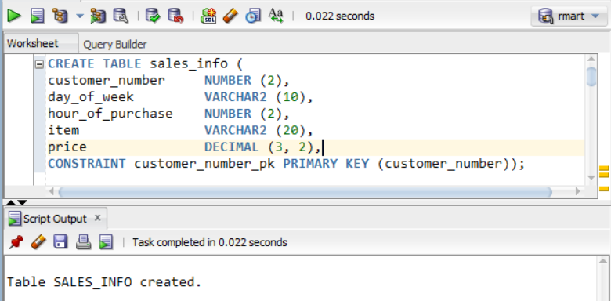

4. Make up 20 records to populate your table.

**INSERT INTO sales_info VALUES (1, 'Saturday', 10, 'bread', 2.49);**

**INSERT INTO sales_info VALUES (2, 'Friday', 14, 'milk', 1.99);**

**INSERT INTO sales_info VALUES (3, 'Monday', 9, 'water', 0.99);**

**INSERT INTO sales_info VALUES (4, 'Tuesday', 18, 'cookies', 1.49);**

**INSERT INTO sales_info VALUES (5, 'Friday', 17, 'strawberries', 1.99);**

**INSERT INTO sales_info VALUES (6, 'Wednesday', 11, 'grapes', 1.99);**

**INSERT INTO sales_info VALUES (7, 'Wednesday', 10, 'bananas', 0.89);**

**INSERT INTO sales_info VALUES (8, 'Monday', 13, 'potatoes', 2.99);**

**INSERT INTO sales_info VALUES (9, 'Tuesday', 15, 'chocolate', 2.49);**

**INSERT INTO sales_info VALUES (10, 'Thursday', 11, 'orange', 1.39);**

**INSERT INTO sales_info VALUES (11, 'Friday', 20, 'lemon', 1.29);**

**INSERT INTO sales_info VALUES (12, 'Saturday', 19, 'garlic', 1.89);**

**INSERT INTO sales_info VALUES (13, 'Sunday', 12, 'onion', 1.89);**

**INSERT INTO sales_info VALUES (14, 'Tuesday', 14, 'lettuce', 2.29);**

**INSERT INTO sales_info VALUES (15, 'Monday', 11, 'apples', 1.59);**

**INSERT INTO sales_info VALUES (16, 'Thurday', 9, 'avocado', 1.49);**

**INSERT INTO sales_info VALUES (17, 'Friday', 17, 'orange juice', 3.49);**

**INSERT INTO sales_info VALUES (18, 'Sunday', 16, 'lemonade', 2.99);**

**INSERT INTO sales_info VALUES (19, 'Wednesday', 18, 'yogurt', 0.99);**

**INSERT INTO sales_info VALUES (20, 'Saturday', 14, 'cupcake', 3.89);**

5. Insert the 20 records into your table.

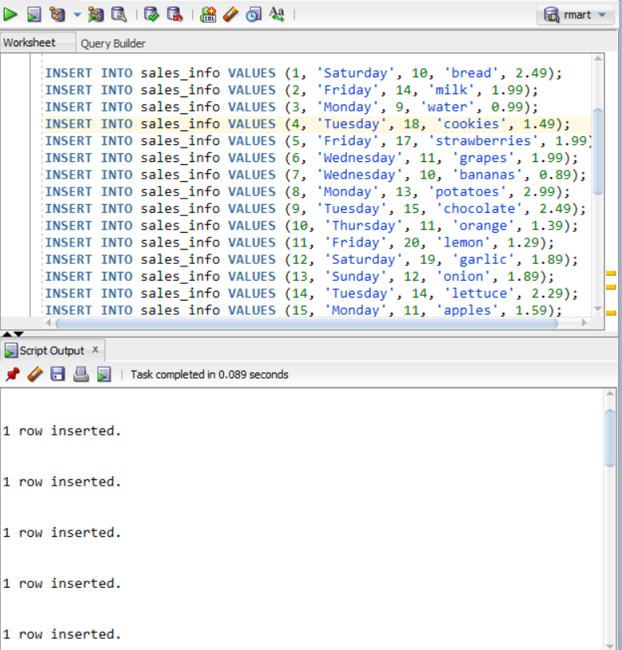

* *SHOWING THE TABLE WITH VALUES:*

**SELECT * FROM sales_info;**

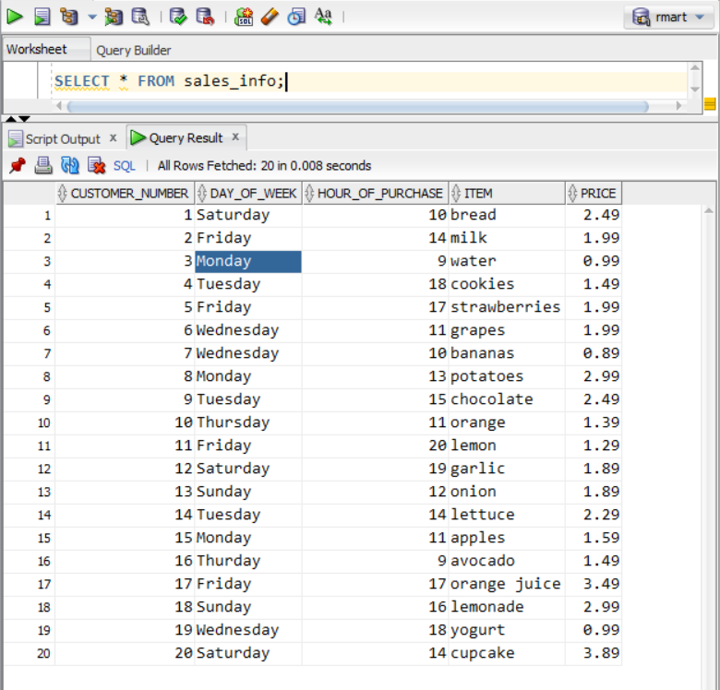

6. Make up a query using CUBE function and make up a query using ROLLUP function.

**SELECT**

**day_of_week,**

**item,**

**SUM (price)**

**FROM sales_info**

**GROUP BY CUBE (day_of_week, item);**

**SELECT**

**day_of_week,**

**hour_of_purchase,**

**item,**

**SUM (price)**

**FROM sales_info**

**GROUP BY ROLLUP (day_of_week, hour_of_purchase, item);**

7. Execute the two queries in the database and show the results.

a) Using the cube function:

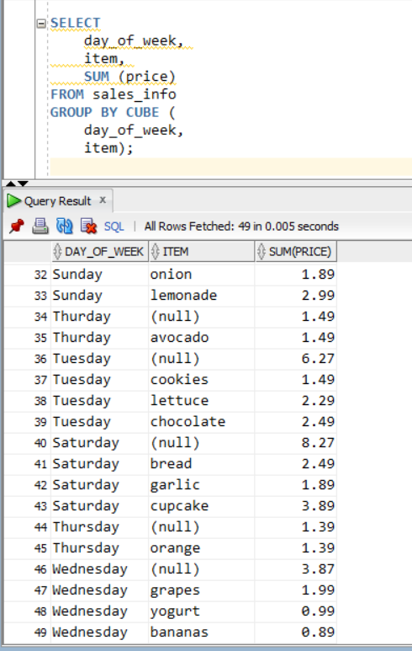

b) Using the rollup function:

